Part(a)

%9:30TR 3C-09/16/2019 samkramer6

%this code is a simple loop that is meant to input 5 values and then find the average of all the values

%%%%%%%%%%%%%%%%%%%%%%%%%%%%%%%%%%%%%%%%%%%%%%%%%%%%%%%%%%%%%%%%%%%%

%Start code

clc;clear;format compact;

value1 = input('Please input the first value: ');

value2 = input('Please input the second value: ');

value3 = input('Please input the third value: ');

value4 = input('Please input the fourth value: ');

value5 = input('Please input the fifth value: ');

total = value1 + value2 + value3 + value4 + value5;

Ybar = total/5;

disp("The average is " +Ybar)

Part (b)

%9:30TR 3C-09/16/2019 samkramer6

%This code is meant to be the same as part B however it integrates matrices

%%%%%%%%%%%%%%%%%%%%%%%%%%%%%%%%%%%%%%%%%%%%%%%%%%%%%%%%%%%%%%%%%%%%%%

%start code

clear;clc;format compact

j = 0;

total = 0;

while j < entries

value = input('Please input the value: ');

total = value + total;

j = j + 1;

end

Ybar = total/entries;

disp("The average value is "+Ybar)

Part (c)

%9:30TR 3C-09/16/2019 samkramer6

%This script is to make part A more robust using a loop

%%%%%%%%%%%%%%%%%%%%%%%%%%%%%%%%%%%%%%%%%%%%%%%%%%%%%%%%%%%%%%%%%%%%%%

%Start Code

clc;clear;format compact;

entries = input('Please input the amount of values you want: ');

j = 0;

v = [];

while j < entries

vi = input('Please input the value: ');

v = [v vi];

j = j + 1;

end

total = sum(v);

Ybar = total/(numel(v));

disp("The average value is "+Ybar)

PART 2

Script 1 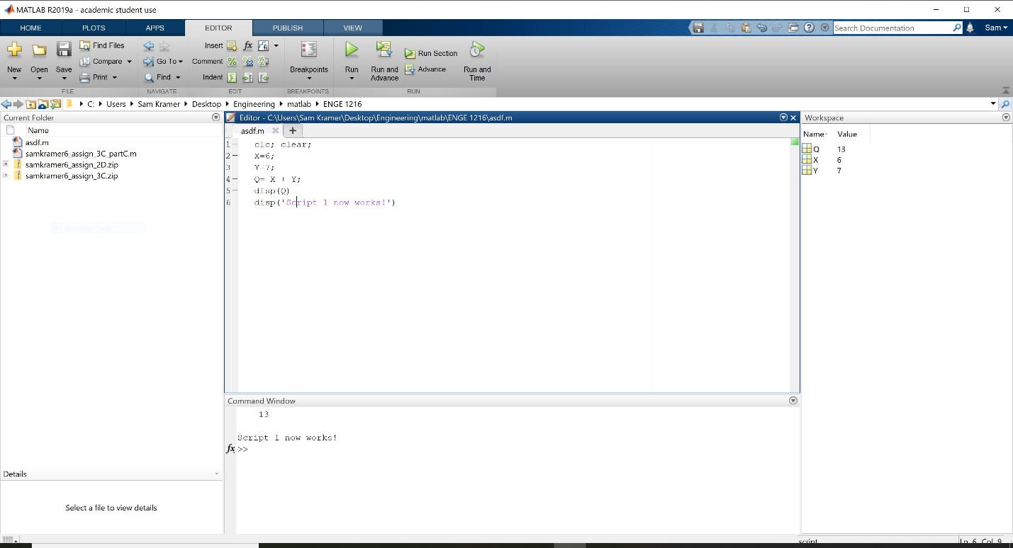

Script 2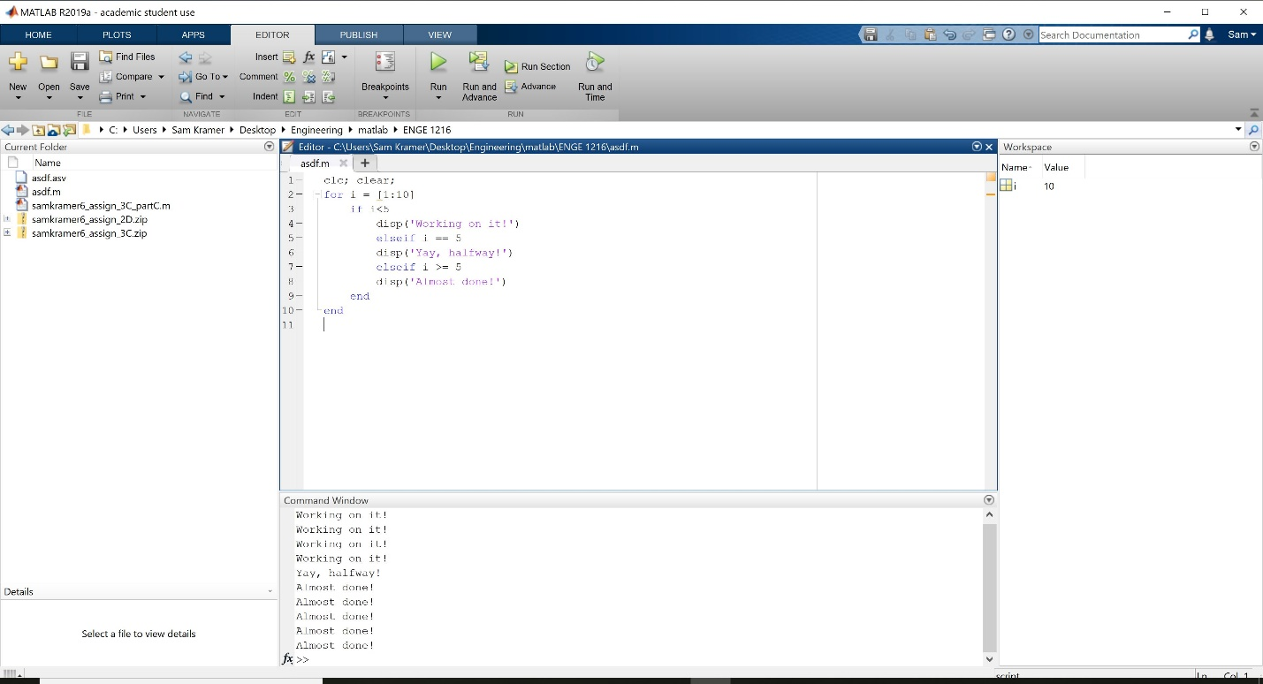

Script 3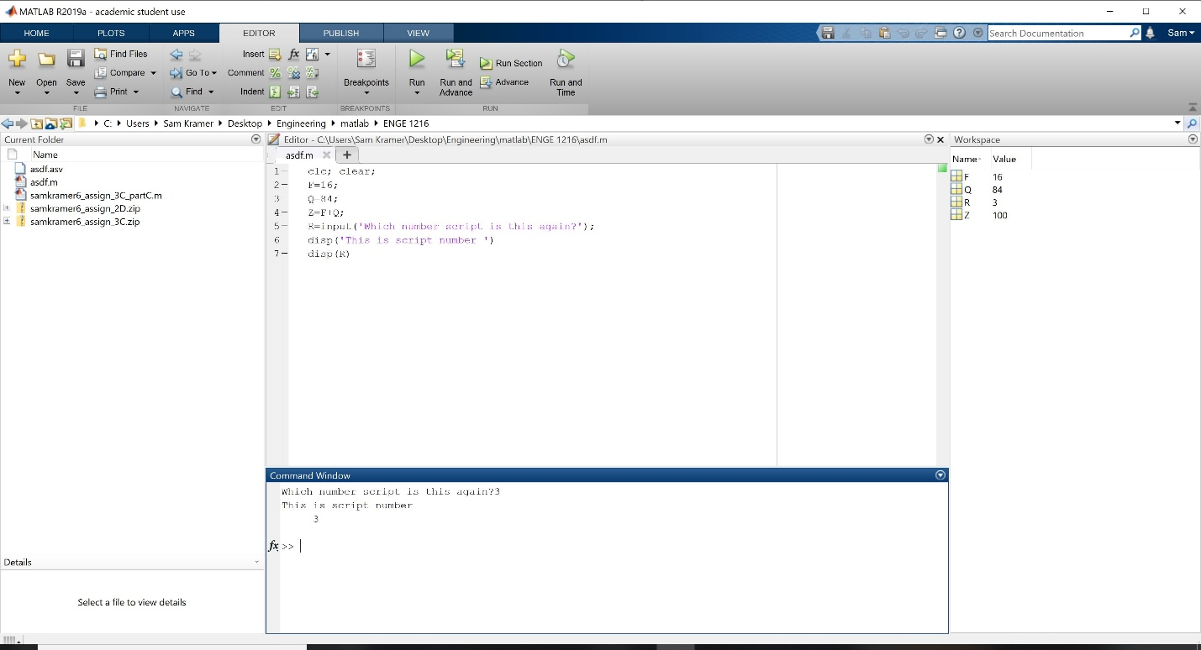

Script 4